**Student Introduction To Code Trather**

**Table of Contents**

Revision History **2**

Forward**3**

Starting An Assignment**4**

Starting With A Unit Test**5**

Starting Without A Unit Test**7**

Submitting Your Unit Test**10**

**Revision History**

|  |  |  |  |
| --- | --- | --- | --- |
| **Date** | **Version #** | **Author** | **Description** |
| 4/3/2023 | 1.0 | Meagan | Initial Draft |

**The following document has been developed to help guide the student with an overview of Code Trather. The student will find a walkthrough of a successful completion and submission of an assignment.**

|  |
| --- |
| **Starting An Assignment** |

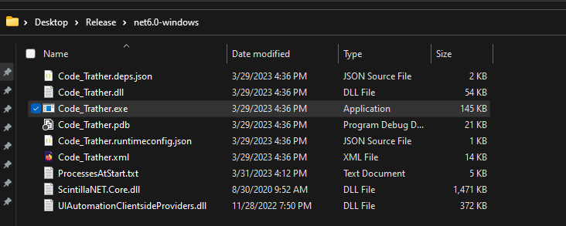

Figure

2. Upon double clicking the .exe, you will see the screen in Figure 2.

1. Navigate to where you have the release folder saved. As seen in Figure 1, the folder is stored on the Desktop. From there double click the .exe file.

Figure

From here, you will select to either start with a unit test or to start without a unit test. Click the link that applies to you to jump to that section.

|  |
| --- |
| **Starting With A Unit Test** |

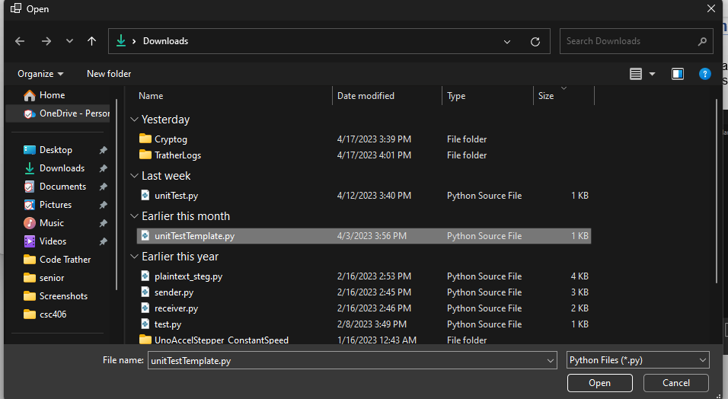

Figure

2. Once ready to test code against test cases students will click the unit test button as seen in Figure 4.

1. If starting with a unit test, a dialog box where you can choose a unit test file will open as seen in Figure 3.

Figure

Figure

3. The student will see the output of the test cases in the right-hand box as seen in Figure 5. The student can now jump to submitting your assignment to see what they need to submit their assignment.

4. You can now skip to submitting your assignment to see how to finish your project.

|  |
| --- |
| **Starting Without A Unit Test** |

Figure

3. If starting without a unit test, the next screen you see will be the one seen in Figure 6.

Figure

4. After typing your code and clicking run, as seen in Figure 7, you will see your output in the right text box. Figure 8 shows what your screen will look like after running your code.

Figure

Figure

4a. If user input is required, the text box and enter button seen in Figure 9 will unlock for the student to use.

|  |
| --- |
| **Submitting Your Assignment** |

1. Upon completion the student can click submit, found under the file drop down, and finish their assignment. See Figure 10 for reference.

Figure

Figure

6. To find the file that needs to be submitted, a student will navigate to C:\\Users\[user]\Downloads\Crytog and they will find a .katb file. This is the file the student can submit.

Figure